Squirrel Canyon

Act 1

By Jordan Hullett & Kevin Boyd

### Description

WDEvelopment’s game as a whole will feature four separate mini-games. The first mini-game, Act 1, will feature the protagonist trapped in a deep canyon. The player’s goal is to ward off three hoards of giant, barbaric squirrels while the protagonist continuously inflates a balloon with a high-powered balloon pump. Each wave of squirrels will attempt to pop the protagonist’s balloon. With each sequential wave, the squirrel hoard will become stronger and quicker. The game will feature normal squirrels and squirrels armed with giant needles. Normal squirrels will be able to deplete the player’s balloon inflation level by one-third, which will increase the time necessary to fully inflate the balloon. If the inflation level has been depleted beyond a certain threshold, the balloon’s structural integrity will be compromised, rendering it useless. Squirrels wielding needles will be able to instantly pop the balloon. A player will fail this mini-game if the balloon’s air is depleted or popped.

Android’s touchscreen interface will allow a player to protect the protagonist’s balloon by allowing the player to grab a squirrel and toss it in a particular direction. When the squirrel lands within the camera’s view, it will explode into a dust cloud capable of slowing oncoming squirrels. Squirrels must be individually touched and thrown, and not brushed away as a hoard. Gravity will be maintained to allow squirrels to fall onto the background. Once a player successfully thwarts three hoards of squirrels, this mini-game will terminate and Squirrel Canyon will move to a cut scene leading into the next mini-game.

In preparation for the Hi Fidelity level prototype, four critical areas of programming were explored: movement, collision detection, touch interaction, and instantiation. These functions have been explored and tested to ensure the successful implementation of the actions on an Android device. Thus far, a background has been put into place along with a single squirrel which may be cloned through prefab instantiation. Collisions have been enabled between the squirrel and the balloon. Upon collision, the balloon disappears through GameObject destruction. The protagonist has also been added to the scene and may receive some animation in the future. Once a complete implementation, with all functions working correctly and simultaneously, has been created, sound and ornamental details will be implemented. Smooth projectile motion will also be studied to create a more realistic experience.

Layer I of Act I has nearly been completed. Basic functionality, medium-to-high grade graphics, and fun effects and elements already comprise the game; however, we have not compiled all major functions into a single instance of our game without our game objects behaving erratically. Our greatest challenge has been putting all of these features into one instance of the game. Instantiation of cloned prefabs also presented a difficult challenge with making the new objects appear and move correctly. Destroying objects, moving objects with translates, and adding assets such as high-quality pictures to Unity has been surprisingly easy for the Act I group.

### Story Board

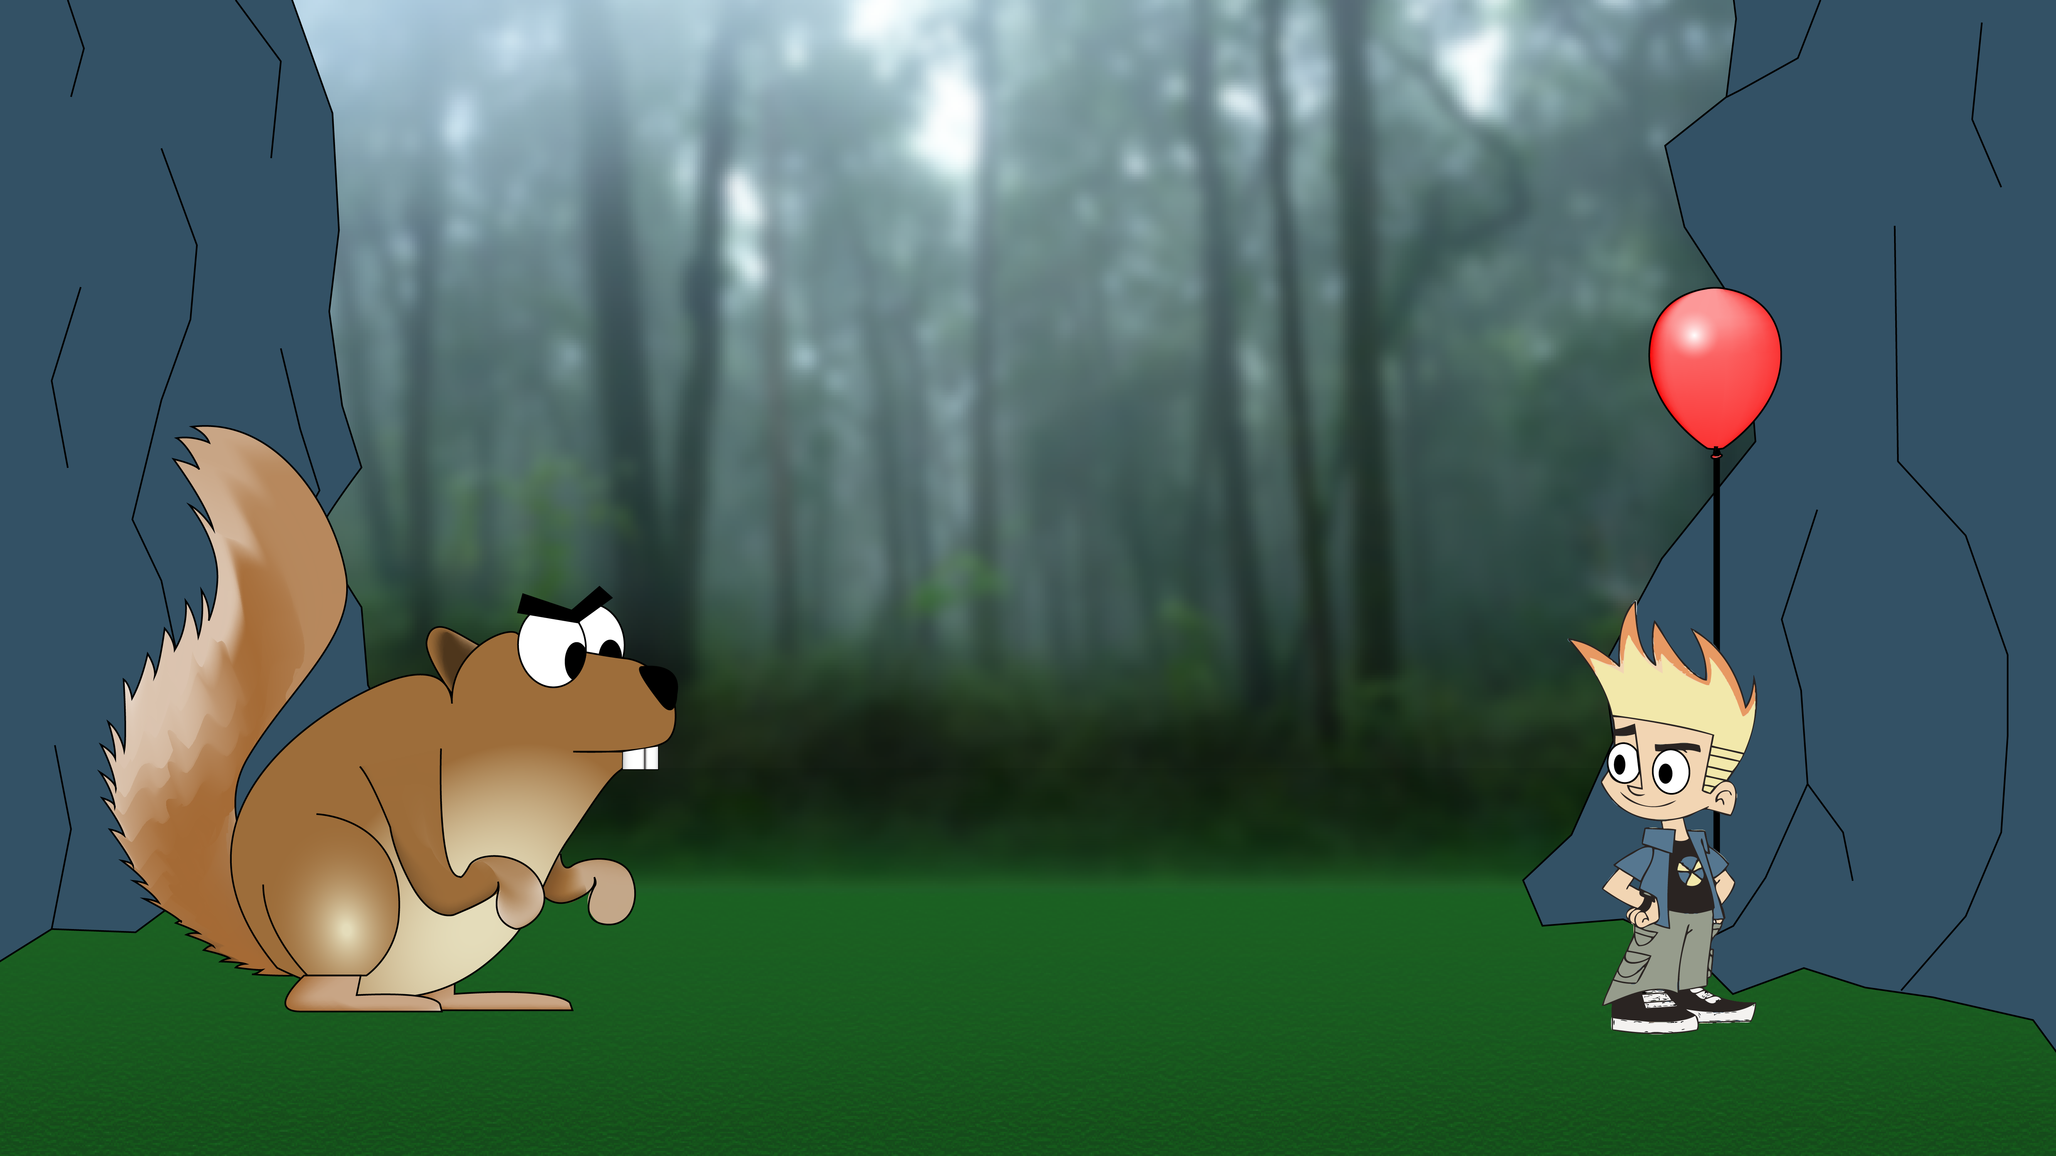

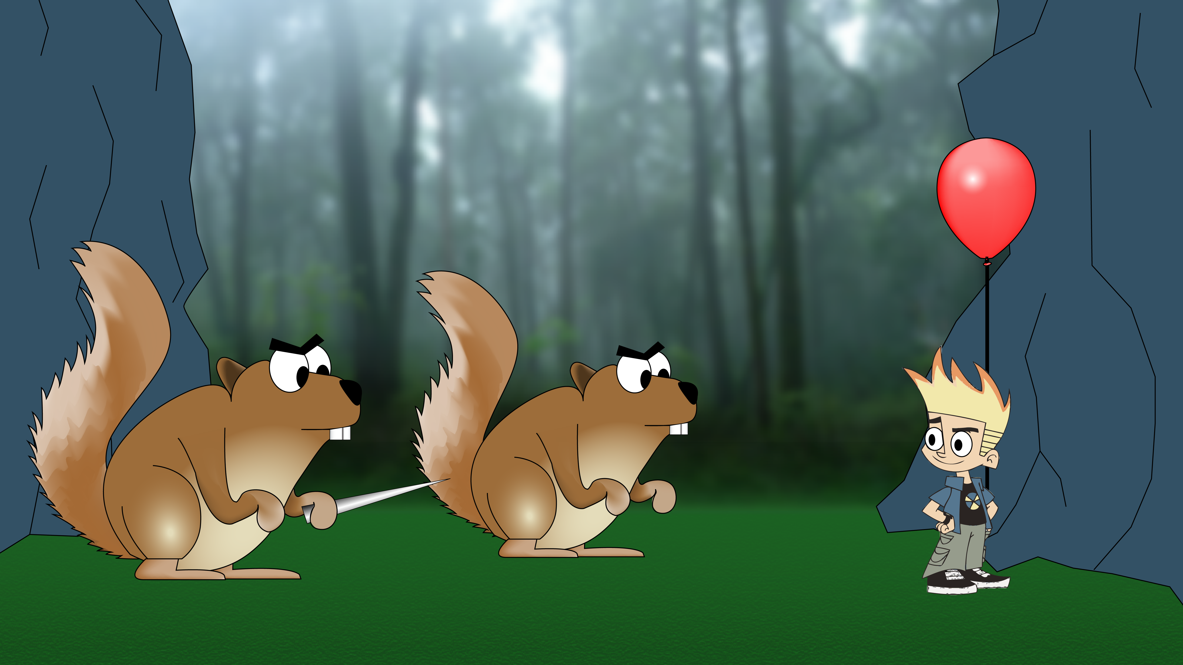

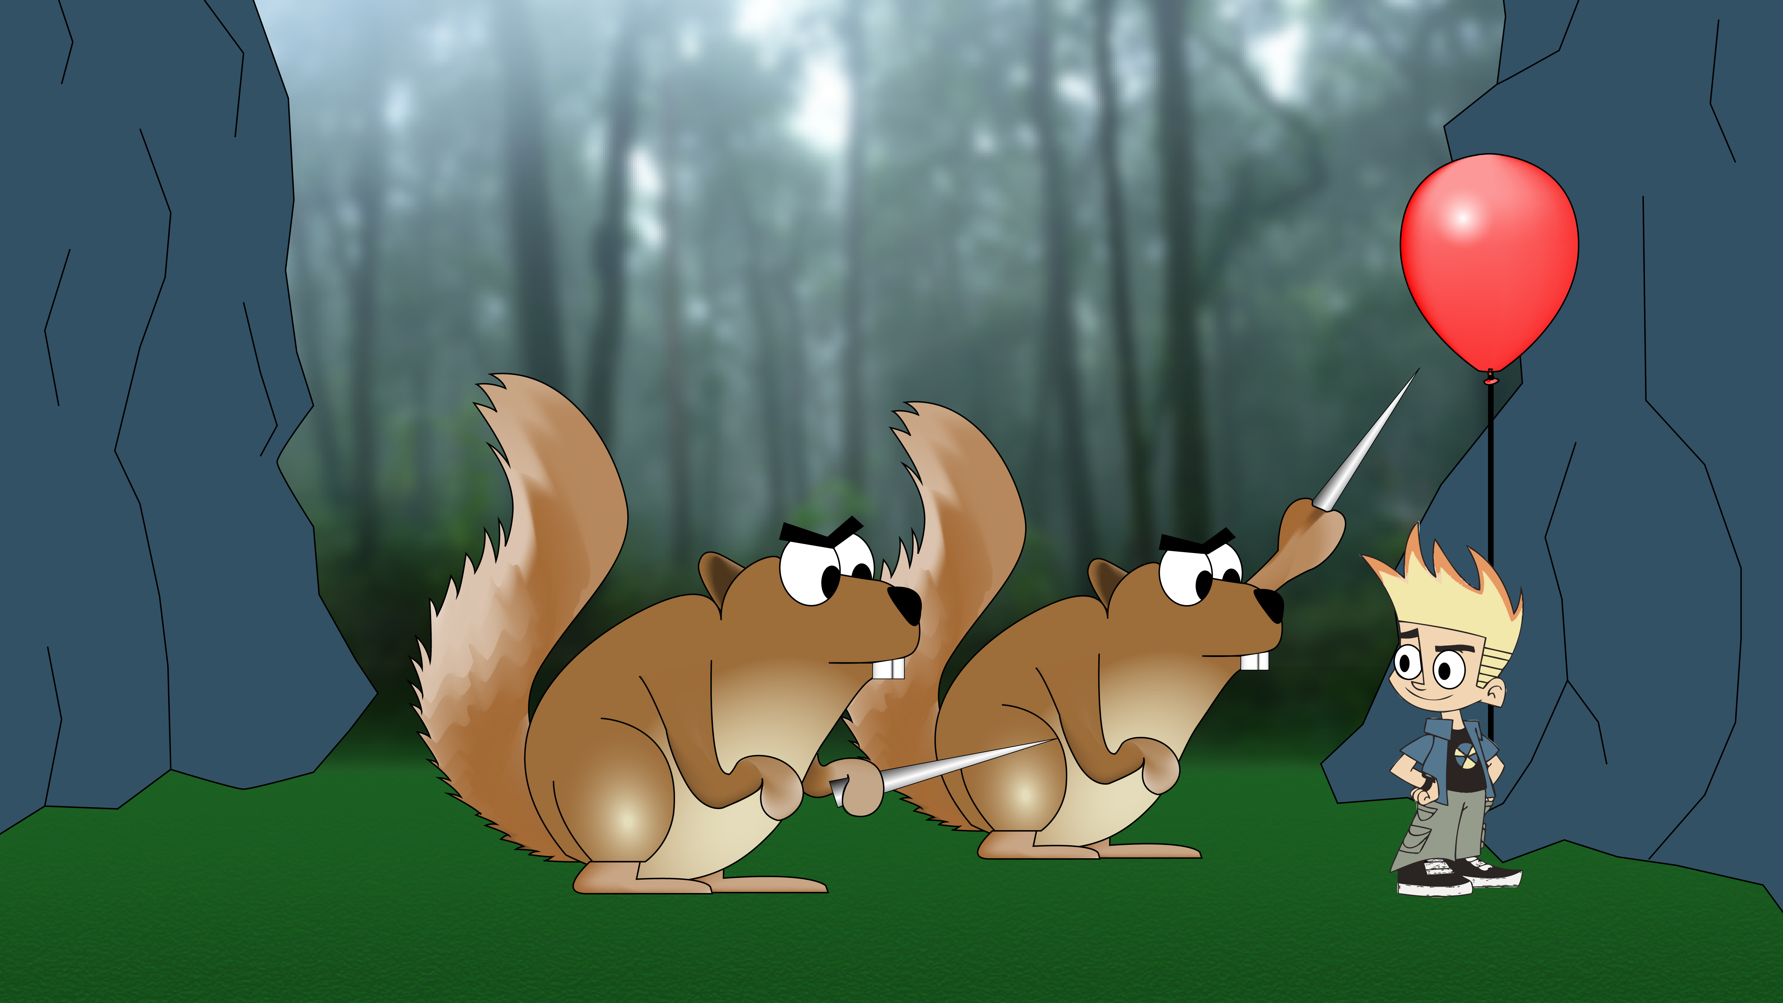

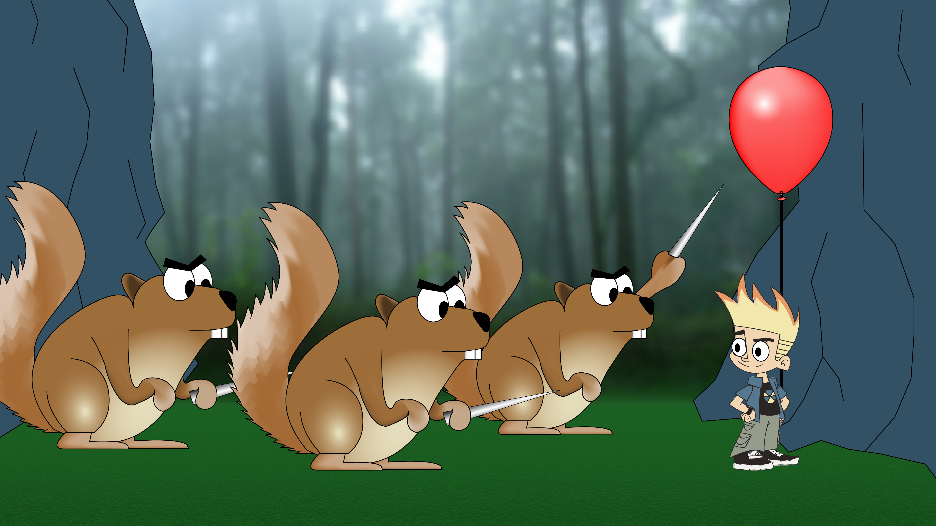

Act 2

By Steven Whaley & Nathan Plotts

### Description

For this portion of the game the player will be controlling the main character as they are carried upwards through the canyon while hanging from a balloon. The game will be a rather simple vertical scrolling 2d game. The objective will be to reach the top of the canyon and proceed to the next level. While traveling to the top of the canyon the player must dodge falling objects like acorns or rocks. Also, there will be ledges on the canyon wall where squirrels will be holding sharp objects to try and pop your balloon with. To move the balloon around, the player will tilt the phone or tablet they are playing on.

To make the background more interesting to the player we will be scrolling most objects in the background. We plan to make the separate objects scroll at different speeds using parallax scrolling. Parallax scrolling is special scrolling technique in 2d scrollers that scrolls foreground images faster than background images to make the game more immersive to the player.

### Story Board

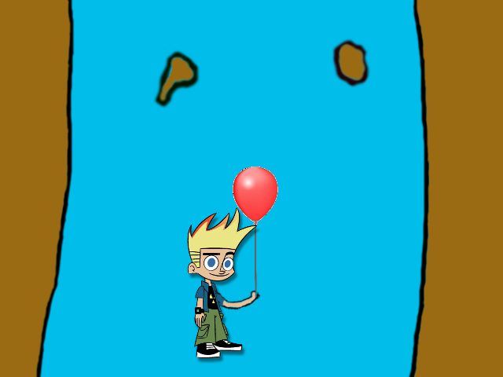

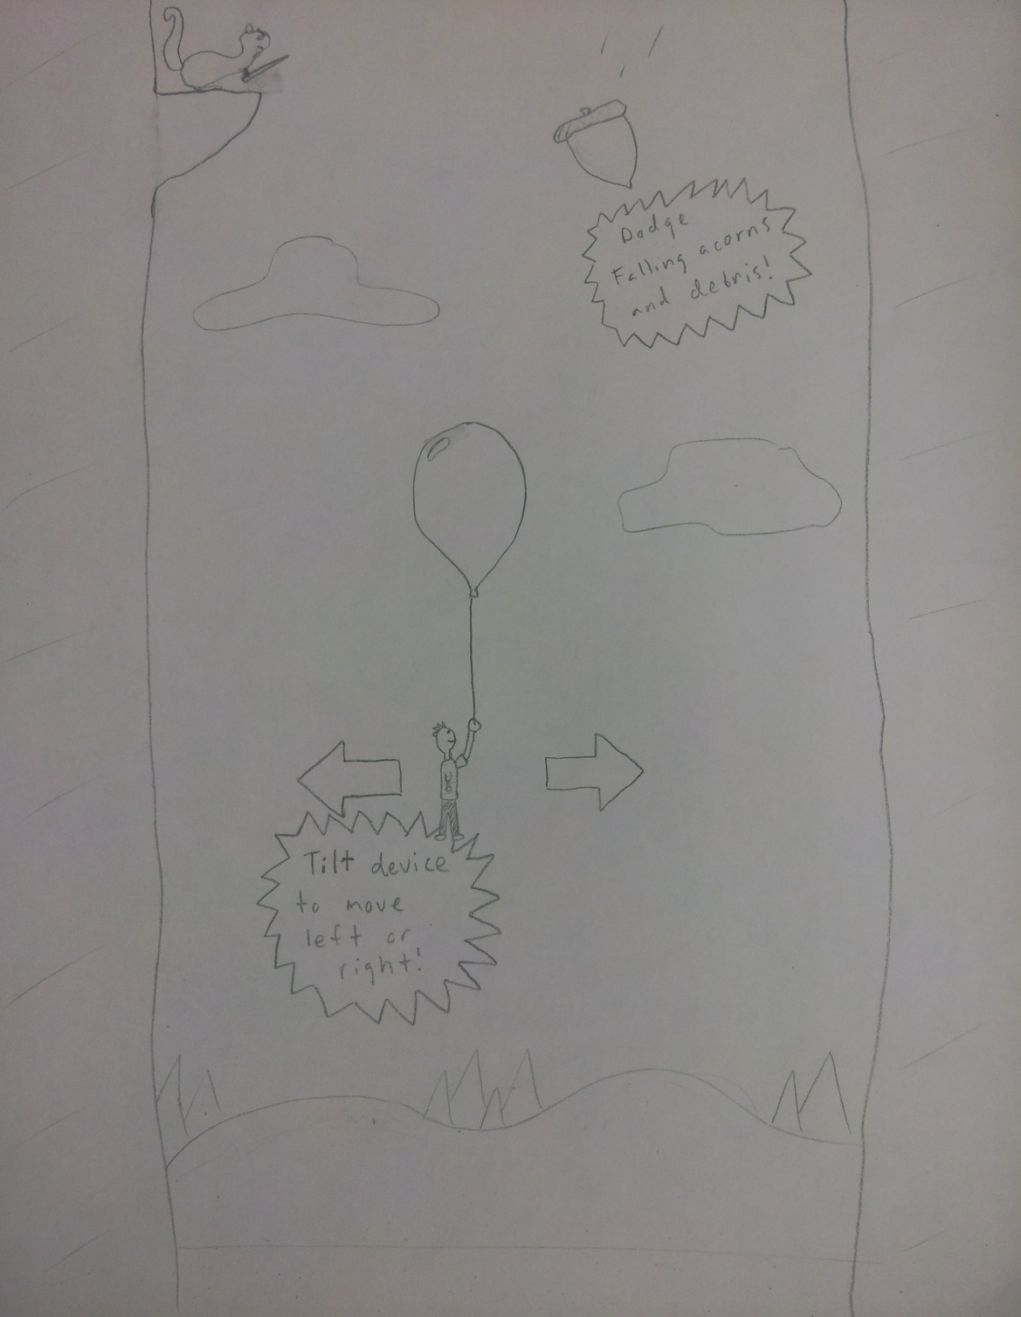Act 3

By Jamal Adams, Tausif Muzaffar, Kelly Perkins

### Description

The mini game that we are creating to be level 3 in the overall game will have the objective of climbing the canyon and collecting apples in a basket to receive points for them and dodging objects that will take away points. The user will use the phone to move the basket back and forth to collect the apples. Once the user reaches the end of this level the points will be added to the overall points.

We currently have it where the squirrels are throwing rocks down. We have found that it is harder to incorporate the device as the controller. We are currently doing finishing touches on level 1. There have currently been no revisions to our previous design. So far everything is going to plan according to the original design.

### Story Board

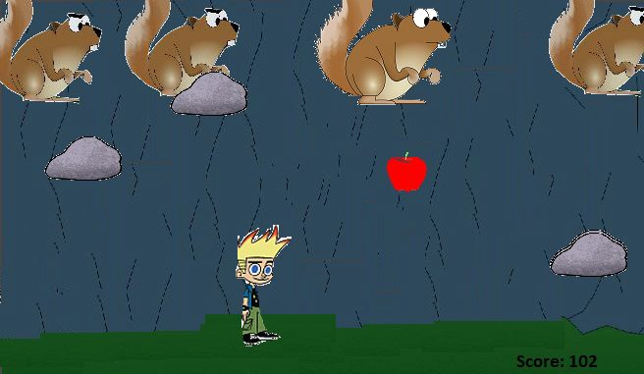

Act 4

By Leo Reyes & Zhitao Gong

### Description

The final act for this series will be escaping the squirrels. After struggling from the bottom of the canyon, the final object will be escaping an army of squirrels. This act will feature a running game, like Me Want Bamboo, The Awesome, etc. Basically our hero will run all the way out, from left to right, the player need to tap the phone screen to make our player to jump over obstacles. Hitting obstacles will slow down your speed, and getting fruits along the way may speed you up.

If our hero is alive until timer is up, then the player wins. Otherwise, the player loses. Shorter time will result in higher scores.

### Story Board

